Photograph of Handgate, Xinjiang by Tsui Yen Hu, 1993, No. 25

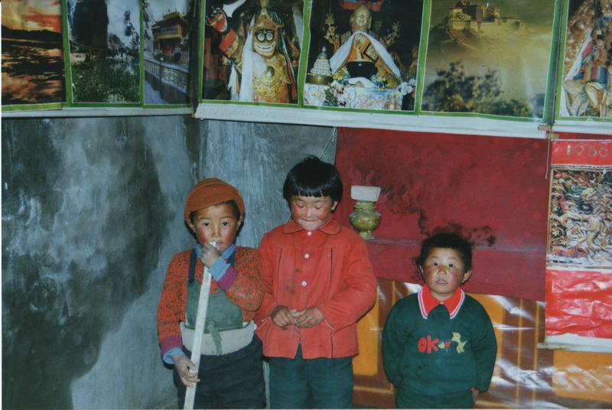

### identifier

f0604a96-2cf5-492d-a6a6-ad96e3c12373

### creator

Tsui Yen Hu

### type

Image

### coverage

Altai district

Handgate

PRC

Xinjiang

### description

Lama's grandchildren, praying or playing. Handgate temple

### publisher

### source

Scanned from colour print held in the archives of the University of Cambridge MacArthur Project "Environmental and Cultural Conservation in Inner Asia", Mongolia and Inner Asia Studies Unit.

### rights

### subject

Buddhism

### date

1993-05-07

### language

### format

image/png

### contributor

### original filename

TsuiYenHu-Handgate-1993-25.png

### relation

### extent

1777x1191 px

3.5 MiB