MacArthur project research sites

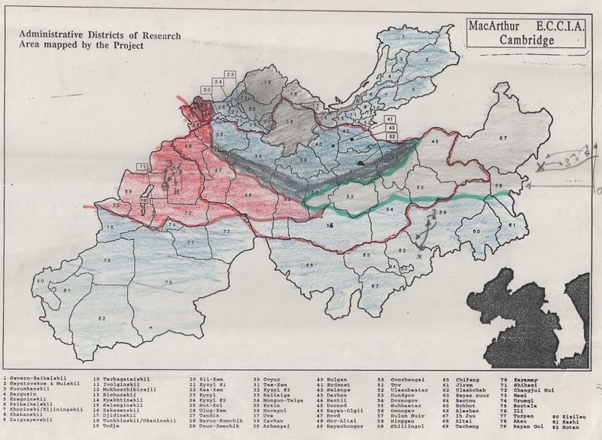

### identifier

f2637465-2b03-4ed9-b2c6-d3c0398b582b

### creator

Sneath, David

### type

Image

### coverage

Inner Asia

### description

Map showing the location of research sites included in the Cambridge MacArthur project “Environmental & Cultural Conservation in Inner Asia”

### publisher

Scanned from an original document held in the archives of the Mongolia and Inner Asia Studies Unit, University of Cambridge.

### source

Scanned from an original document held in the archives of the Mongolia and Inner Asia Studies Unit, University of Cambridge.

### rights

research planning

maps

### subject

### date

ca. 1992

### language

### original filename

macarthur-research-areas.png

### relation

### extent

10.6 MiB

2926x2141 px

### contributor

### format

Image

### modified

2017-05-25 10:52:20