Summer: Figures from “Living with Herds”

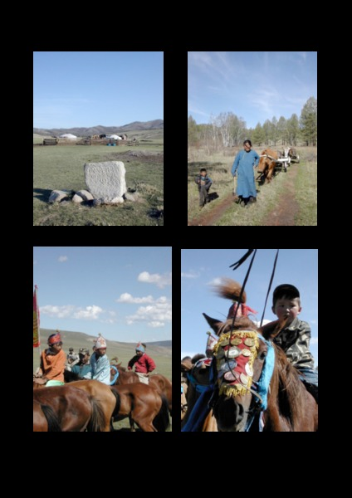

### identifier

f35a2605-e066-4650-97d7-bddc2f5a6841

### creator

Fijn, Natasha

### type

Text

### coverage

Mongolia

### description

### publisher

### source

<http://www.cambridge.org/us/academic/subjects/archaeology/archaeology-europe-and-near-and-middle-east/living-herds-human-animal-coexistence-mongolia?format=HB&isbn=9781107000902#Je3whAJbJX4jZR5A.97>

### rights

These resources are provided free of charge by Cambridge University Press with permission of the author of the corresponding work, but are subject to copyright. You are permitted to view, print and download these resources for your own personal use only, provided any copyright lines on the resources are not removed or altered in any way.

### subject

### date

2011

### language

English

### format

application/pdf

### contributor

### original filename

9849_Summer.pdf

### remote embed url

### relation

### extent

872.4KiB