Caroline Humphrey Mongolia Super8 film no. 6

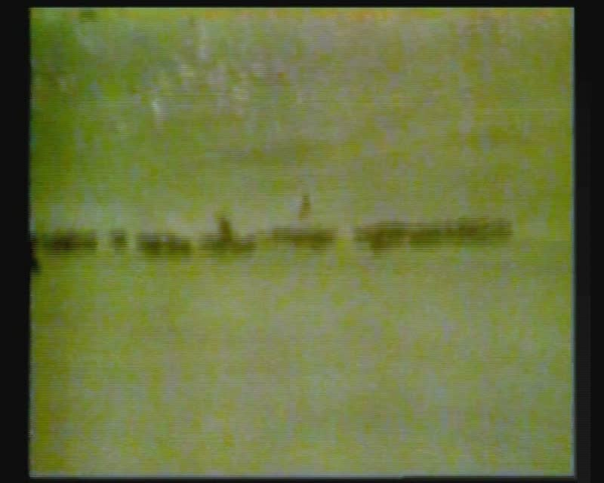

### identifier

f3832a1e-ac0c-4c44-860f-80380781c2e8

### creator

Humphrey, Caroline

### type

Moving Image

### coverage

Mongolia

### description

Herding cows, child and women riding; ox-drawn cart; women walking next to an apartment building.

### publisher

MIASU

### source

Digitized from a VCR transfer tape held at the Mongolia and Inner Asia Studies Unit, University of Cambridge

### rights

Copyright Caroline Humphrey

### subject

herding

ox-carts

riding horses

### date

ca. 1970s

### language

None

### original filename

humphrey-super8-mongolia-06.mp4

### extent

964.0 MiB

216.320000

### format

video/mp4

### modified

2017-06-16 09:57:39

### alternate url

https://archive.org/embed/f3832a1e-ac0c-4c44-860f-80380781c2e8