Photographs of Dashbalbar sum, No. 37

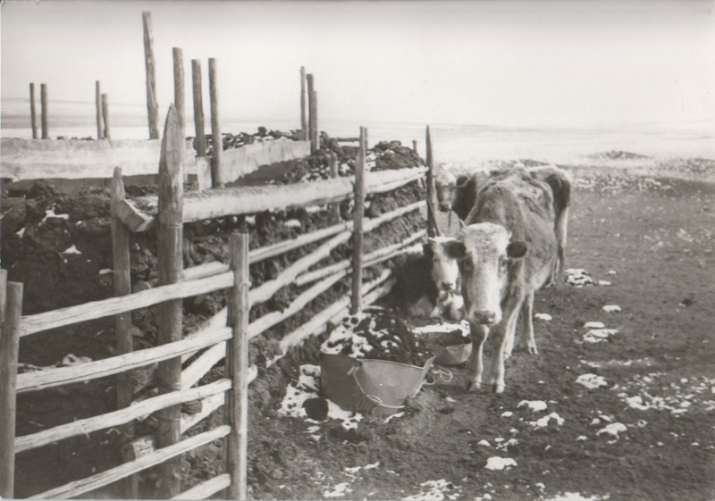

### identifier

f4c022c4-de5d-46e8-a3e7-046429e43fa5

### creator

Batbuyan B.

### type

Image

### coverage

Dashbalbar sum

Dornod aimag

Mongolia

### description

Cattle at a fence and enclosure made of dung.

### publisher

### source

Scanned from a photographic print held in the archives of the Mongolia and Inner Asia Studies Unit, University of Cambridge.

### rights

### subject

livestock enclosures

pastoral camps

### date

1993, spring

### language

### format

image/png

### contributor

### original filename

bair-batbuyan-photos-37.png

### relation

### extent

1514x1061 px

2.3 MiB