Photographs of Dashbalbar sum, No. 50

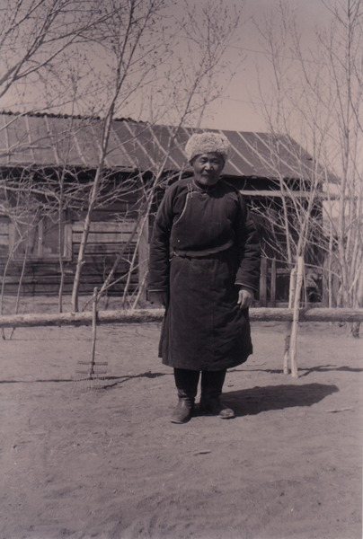

### identifier

f5983254-f957-4d70-8253-b23c6d7cba7d

### creator

Batbuyan B.

### type

Image

### coverage

Dashbalbar sum

Dornod aimag

Mongolia

### description

Purevdorj, the “Knowledgeable Old Person” of Batbuyan’s questionnaire.

### publisher

### source

Scanned from a photographic print held in the archives of the Mongolia and Inner Asia Studies Unit, University of Cambridge.

### rights

### subject

research participants

### date

ca. 2001

### language

### format

image/png

### contributor

### original filename

bair-batbuyan-photos-50.png

### relation

### extent

1182x1756 px

3.0 MiB