Shearing sheep - Noogii and Enkhee, Sainshand sum, Dornogovi aimag

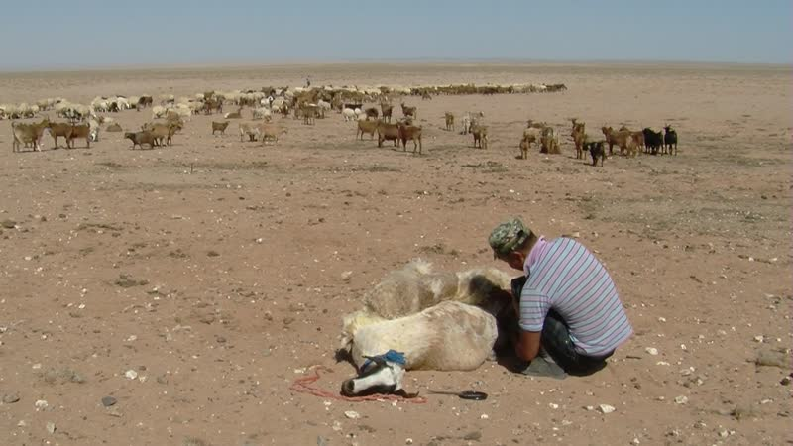

### identifier

f5cd3d0a-3727-434e-b094-3b6a5eae4f99

### creator

Thrift, Eric

### type

Moving Image

### coverage

Mongolia

Dornogovi aimag

Sainshand sum

### description

The recordings in this series depict shearing sheep and milking camels at Noogi and Enkhee's place.

### publisher

### source

### rights

### subject

Pastoralism Videos

Shearing Sheep

Milking Camels

Noogii-Enkhee

### date

2012-06-30

### language

### format

inode/directory

### modified

2018-03-02 09:37:44

### original filename

PastoralismVideos--2012-06-30--ShearingSheep--MilkingCamels--Noogii-Enkhee--Dornogovi-Sainshand.vclips

### table of contents

|  |  |  |
| --- | --- | --- |
| time | clip | description |
| 0:00:00 | 300G0005 01 | Nar-Od follows Enkhee as she carries her rope ties and heads over to round up the sheep that will be shorn. As she drives the sheep closer to the yurt, Noogi captures a sheep and calls Enkhee to come tie up its legs. Noogii catches another sheep and binds its legs and begins shearing. Enkhee comes back from the home and begins shearing a sheep as well, while chatting with Nar-Od. |
| 0:13:53 | 300G0005 02 | Enkhee continues shearing the sheep. Noogii completes shearing a sheep and begins shearing another one. |
| 0:27:46 | 300G0005 03 | Noogii shears sheep as his nephew watches. Enkhee completes shearing a sheep and begins shearing another one. |
| 0:41:40 | 300G0005 04 | Enkhee continues shearing the sheep. Noogii comes over and helps cutting the wool from the back and rump. |
| 0:55:34 | 300G0005 05 | Enkhee and Noogii finish shearing the sheep, and with their nephew gather up the shorn wool and pack it into a large sack. Noogii and Enkhee catch the next sheep to be shorn, as Nar-Od carries the bindings for their legs. Noogii begins shearing a sheep, followed by Enkhee. |
| 1:09:28 | 300G0005 06 | Enkhee finishes shearing a sheep and releases it. She walks over to the next sheep to be shorn, as Noogii works at shearing a sheep and his nephew watches. The family's two preschool children come out to see what is going on. Noogii sharpens his scissors, then catches and binds another sheep, and returns to shearing. Enkhee continues shearing and chatting with Nar-Od. |
| 1:23:21 | 300G0005 07 | Enkhee continues shearing the sheep. Noogii continues shearing a separate sheep some distance away. |
| 1:37:15 | 300G0005 08 | Enkhee finishes shearing a sheep, as Noogii continues shearing another one. The two nephews gather up the wool and stuff it into the sack. Enkhee begins shearing another sheep. |
| 1:51:08 | 300G0005 09 | Noogii shears a sheep as the two nephews watch. Enkhee shears a different sheep as Nar-Od watches. |
| 2:00:09 | 300G0005 10 | Enkhee continues shearing a sheep. |
| 2:02:14 | 300G0006 01 | Enkhee continues shearing a sheep. Noogii and the nephews gather up the wool. |
| 2:03:52 | 300G0007 01 | Noogii carries the large sack of wool over toward the yurt, leaving it on the ground outside the home. |
| 2:05:52 | 300G0008 01 | Enkhee exits the yurt carrying a metal pail. She is followed by the nephews and by Nar-Od. After waiting a couple of minutes for the females to arrive as they return from grazing beyond the hill, Enkhee releases the first calf and allows it to suckle. She then binds the hind legs of its mother and begins milking. Enkhee heads over to the next camel to be milked. She shows the amount of milk in her pail. Enkhee milks the camel. |
| 2:19:45 | 300G0008 02 | Enkhee milks another camel, then pours the milk from her pail into a pot carried by Nar-Od. She milks two more camels, pours out the milk again, milks another camel, pours out the milk, then begins milking another camel. |
| 2:33:39 | 300G0008 03 | Enkhee continues milking the last camel. Nar-Od tries milking, but quickly gives up. Enkhee and Nar-Od carry the empty bucket and full pot of milk into the yurt, and place them on the floor. Enkhee starts pouring tea for the children. |
| 2:37:01 | 300G0009 01 | Enkhee pours fresh camel milk into the plastic container of *tsagaa* (fermented milk) at the rear of the yurt, then churns it several times. |