9408

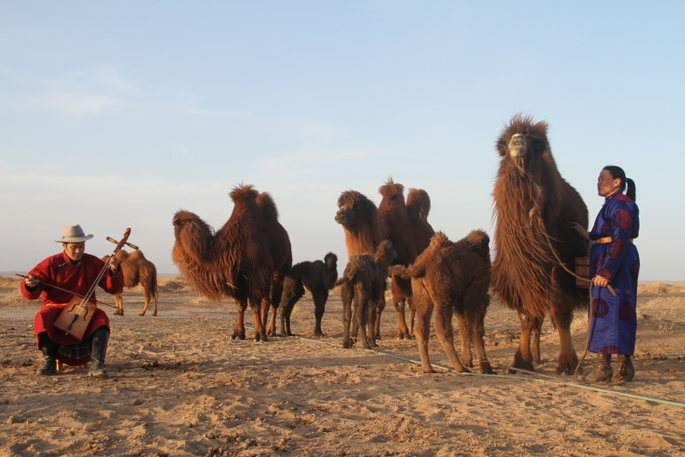

### identifier

f7a507d8-f7b3-4c5d-b340-f23d405ab7e7

### creator

Boldbaatar, Yu.

### type

Image

### coverage

Mongolia

Ömnögovi aimag

Khankhongor sum

### description

Using the melody of Morin Khuur for coaxing the mare-camel and orphan calf -2 (Khankhongor)

### publisher

### source

https://ich.unesco.org/img/photo/src/09408.jpg

### rights

### subject

### date

2011

### language

### original filename

09408.jpg

### extent

6.0 MiB

5184x3456 px

### format

image/jpeg

### modified

2016-02-24 14:46:14