Harvesting tsulikhir (Agriophyllum squarrosum)

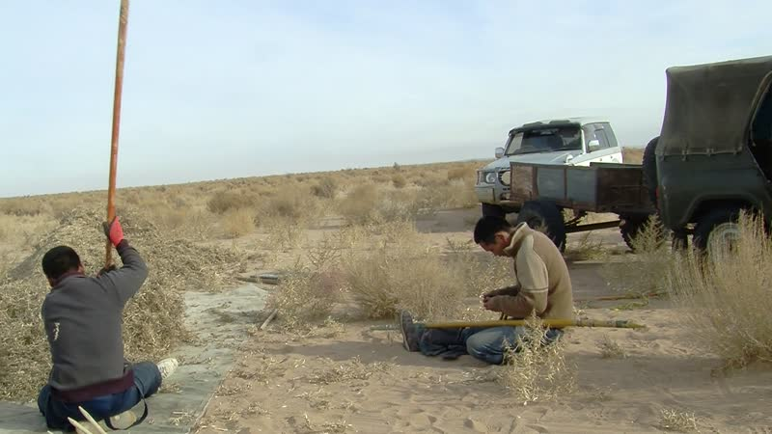

### identifier

f7ecb35b-0967-41bd-9792-29576ddb6c07

### creator

Thrift, Eric

### type

Moving Image

### coverage

Mongolia

Dornogovi aimag

### description

This series of audiovisual recordings documents tsulikhir harvest by Eldev and Odsüren from Khamar Monastery. My sister-in-law Narangiimaa also appears in the videos. Tsulikhir (Agriophyllum squarrosum) is a thorny desert annual with a deep root system, adapted to sand dunes. The tiny seeds of the plant can be roasted and milled, then mixed with milk tea. As tsulikhir is said to present strong therapeutic benefits for the inner organs, it is in considerable demand; some people from Khamar Monastery claimed to harvest up to 500 kg of seeds, selling the milled flour in 100 g packets for 2000 MNT (approximately $1.40). This year's harvest is particularly good; people say that tsulikhir only grows enough to be harvested once every two or three years. The seeds are harvested in autumn, once the plants have dried out but before the seeds have fallen to the ground. The plants are gathered up using broad rakes pushed with long handles, separating each plant from its roots. The gathered plants are then placed on a tarpaulin and threshed (beaten with sticks in order to cause the seeds to fall off the stems), then winnowed (tossed up in the air to allow the lighter chaff to blow away in the wind). Eldev whistles during the winnowing in order to summon the wind. The grains are passed through a fine sieve and gathered in a basin.

### publisher

### source

### rights

### subject

Pastoralism Videos

Tsulikhir Harvest

### date

2012-11-20

### language

### modified

2018-01-18 15:18:55

### table of contents

|  |  |  |
| --- | --- | --- |
| time | clip | description |
| 0:00:00 | 300G0244 01 |  |
| 0:13:53 | 300G0244 02 |  |
| 0:27:47 | 300G0244 03 |  |
| 0:41:40 | 300G0244 04 |  |
| 0:55:34 | 300G0244 05 |  |
| 1:07:48 | 300G0244 06 |  |
| 1:21:41 | 300G0244 07 |  |
| 1:35:35 | 300G0244 08 |  |
| 1:49:29 | 300G0244 09 |  |
| 2:01:14 | 300G0245 01 |  |
| 2:15:08 | 300G0245 02 |  |
| 2:22:31 | 300G0246 01 |  |
| 2:36:25 | 300G0246 02 |  |