Across Mongolian plains; a naturalist's account of China's "great northwest"

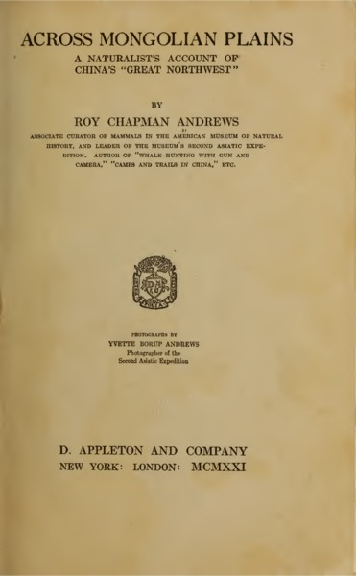

### identifier

f85e3315-94ee-443a-96f2-f9b839495025

### creator

Andrews, Roy Chapman

### type

Text

### coverage

Mongolia

PRC

### description

A popular narrative of the second Asiatic expedition of the American Museum of Natural History, 1918-1919.

### publisher

D. Appleton and Company

### source

<https://archive.org/details/acrossmongolianp00andr>

### rights

Public domain

### subject

expeditions

### date

1921

### language

English

### original filename

acrossmongolianp00andr.pdf

### extent

23.4 MiB

### remote embed url

https://archive.org/embed/acrossmongolianp00andr

### format

application/pdf

### modified

2017-10-09 13:07:37