ECCIA project weekly timetable for June 1992

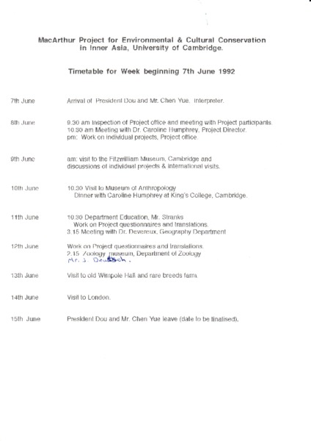

### identifier

f9458c8b-8283-4715-a3c2-b6e38b2a1eb2

### creator

### type

Text

### coverage

### description

### publisher

### source

Scanned from an original document held in the archives of the Mongolia and Inner Asia Studies Unit, University of Cambridge.

### rights

### subject

### date

ca. 1992

### language

### original filename

macarthur-weekly-timetable-june-1992.pdf

### relation

### extent

400.8 KiB

### contributor

### format

application/pdf

### modified

2017-05-25 10:54:10