“Гоё” тараг, “Гоё” технологи

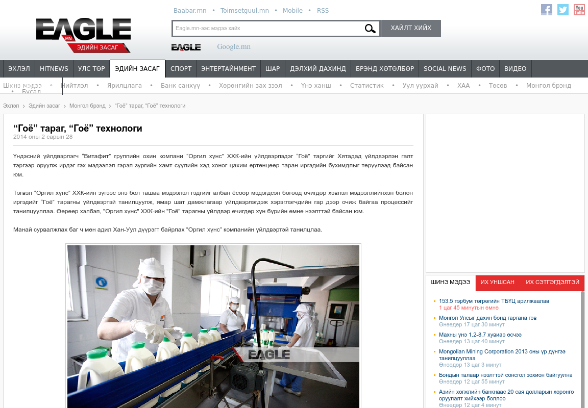

### identifier

fc785722-dcca-43cb-9fcc-08da0a33db23

### creator

### type

Text

### coverage

Mongolia

### description

### publisher

### source

http://economics.eagle.mn/content/read/13642.htm

### rights

### subject

Mongolia

dairy

nationalism

social media

### date

17 Mar 2014 19:43:40

### language

Mongolian

### format

text/plain

### modified

2018-01-11 14:12:43

### original filename

eagle.mn.Goyo_tarag_goyo_tekhnologi.url

### extent

48.0 B