Horse branding celebration in Yeröö

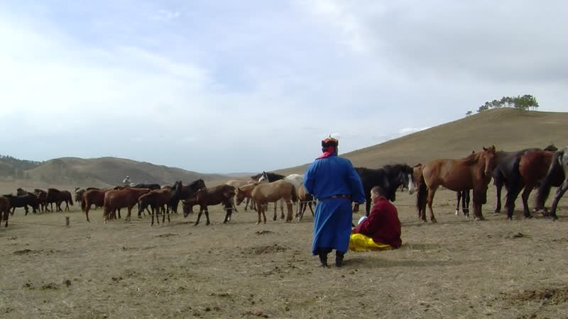

### identifier

fcb4e4a3-57a3-4944-a145-22cd9e29c784

### creator

Thrift, Eric

### type

Moving Image

### coverage

Mongolia

Selenge aimag

Yeröö sum

### description

This series of recordings documents a branding ceremony for the foals belonging to a wealthy businessman from Nalaikh. There are three yurts set up at this site; two belong to the herder households responsible for managing the owner's livestock, which are separated into horses and sheep/goats, while the third is for reception of visitors by the owner. The branding of foals by this major horse owner is an annual event attended by local herders and horse traders, as well as by other businessmen friends and relatives from the city. The event begins with the rounding up of the foals in the morning, followed by the chanting of prayers and blessings by a lama from the city. Subsequently the horses are branded, with the brand eventually being placed in a bucket of airag (fermented mare's milk) to cool it off. Afterwards each participant in the ceremony chooses one foal, and collectively the foals are sent off to race as far as the mountain, the winning horse bringing good luck to whoever chose it. Following this the reception (nair) begins (not recorded here due to technical difficulties). The reception includes musical performances by popular singers Mönkhbat and Erdenetungalag.

### publisher

### source

### rights

### subject

Pastoralism Videos

Horse Branding Ritual

### date

2012-09-26

### language

### remote embed url

https://archive.org/embed/fcb4e4a3-57a3-4944-a145-22cd9e29c784

### format

inode/directory

### modified

2018-01-18 15:02:05

### original filename

PastoralismVideos--2012-09-26--HorseBrandingRitual--Selenge-Yeroo.vclips

### table of contents

|  |  |  |
| --- | --- | --- |
| time | clip | description |
| 0:00:00 | 300G0189 01 |  |
| 0:05:19 | 300G0191 01 |  |
| 0:09:27 | 300G0192 01 |  |
| 0:12:47 | 300G0193 01 |  |
| 0:13:40 | 300G0194 01 |  |
| 0:27:34 | 300G0194 02 |  |
| 0:32:54 | 300G0195 01 |  |
| 0:32:55 | 300G0196 01 |  |
| 0:34:40 | 300G0197 01 |  |
| 0:35:10 | 300G0198 01 |  |
| 0:37:53 | 300G0199 01 |  |
| 0:48:28 | 300G0200 01 |  |
| 0:53:22 | 300G0201 01 |  |
| 1:07:16 | 300G0201 02 |  |
| 1:19:09 | 300G0203 01 |  |
| 1:33:03 | 300G0203 02 |  |
| 1:41:07 | 300G0204 01 |  |