ITH-11-6.COM-CONF.206-8Corr.Add.-EN

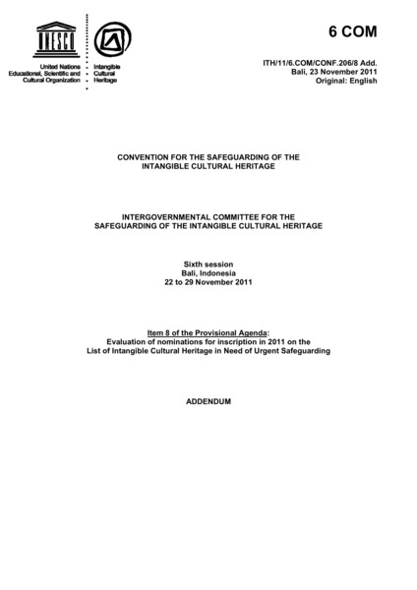

### identifier

fd53e1cf-9fd9-421e-84c5-122514d282fd

### creator

UNESCO Intergovernmental Committee for the Safeguarding of the Intangible Cultural Heritage

### type

Text

### coverage

Mongolia

### description

Withdrawal of the file “Coaxing ritual for camel caves”.

### publisher

### source

### rights

### subject

### date

2011

### language

English

### original filename

ITH-11-6.COM-CONF.206-8Corr.Add.-EN.pdf

### extent

409.9 KiB

### format

application/pdf

### modified

2016-02-24 14:44:08