Photograph from Inner Mongolia, No. 01

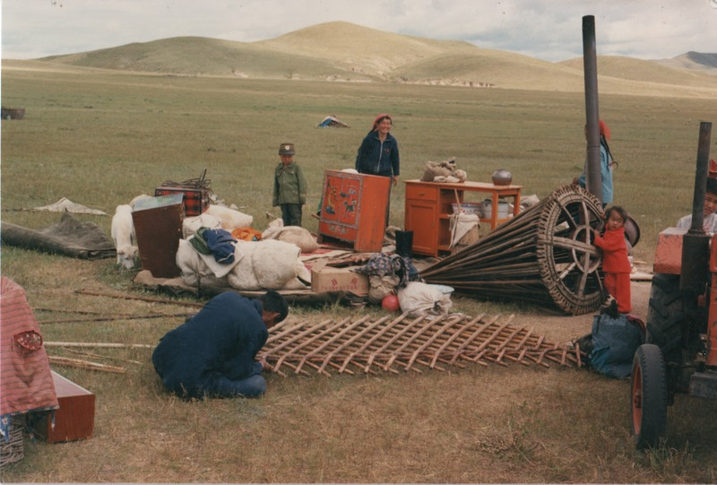

### identifier

fd777749-88b2-4c26-b437-e4aa4bfc3e82

### creator

Sneath, David

### type

Image

### coverage

Inner Mongolia

PRC

### description

Herder household moving camps.

### publisher

### source

Scanned from a photographic print held in the archives of the Mongolia and Inner Asia Studies Unit, University of Cambridge.

### rights

### subject

moving

### date

ca. 1988

### language

### original filename

sneath-inner-mongolia-1980s.png_01.png

### relation

### extent

3.1 MiB

1747x1182 px

### contributor

### format

image/png

### modified

2017-05-25 10:56:38