Witsen - map of Tartaria

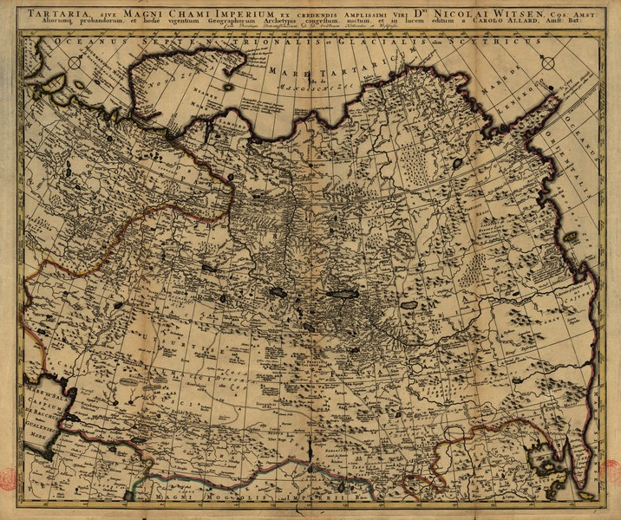

### identifier

fe0d1f3b-50be-4ace-b89c-f095828ef11d

### creator

Witsen, Nicolaes

### type

Image

### coverage

Inner Asia

### description

Tartaria, sive magni Chami Imperium ex credendis amplissimi viri, Amsterdam 1705

### publisher

Allard, Carolo

### source

<http://purl.pt/4107/3/>

<https://commons.wikimedia.org/wiki/File:Witsen_-_Tartaria.jpg>

### rights

Public domain

### subject

maps

Tartaria

### date

1705

### language

Latin

### format

image/jpeg

### modified

2018-03-16 16:35:15

### extent

3.0 MiB

3817x3201 px