1941538. Batyr Elistaev, A Morning Prayer

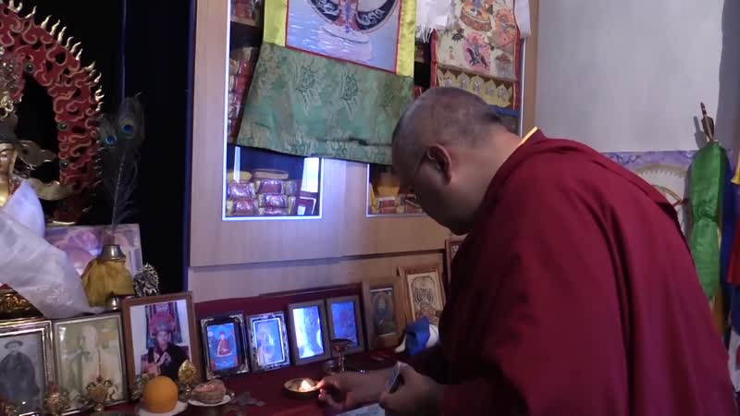

### identifier

1820bb36-30e5-497a-9545-f5a307574f96

### creator

Kalmyk Cultural Heritage Documentation Project

### type

Moving Image

### coverage

Kalmykia

Russia

### description

### publisher

University of Cambridge

### source

<http://www.kalmykheritage.socanth.cam.ac.uk>

### rights

Copyright Kalmyk Cultural Heritage Documentation Project. Licensed under a Creative Commons BY-NC-ND Unported license.

### subject

Buddhism

Kalmyks

### date

2015-04-29 05:21:05

### language

### extent

128.9 MiB

345.480000

### format

video/mp4

### modified

2017-05-27 10:45:44

### original filename

1941550.mp4

### remote embed url

http://sms.cam.ac.uk/media/1941538/embed

### public

FALSE