Vitafit factory tour image - v3ftj0huhqfr2ds3cgl264l1f l

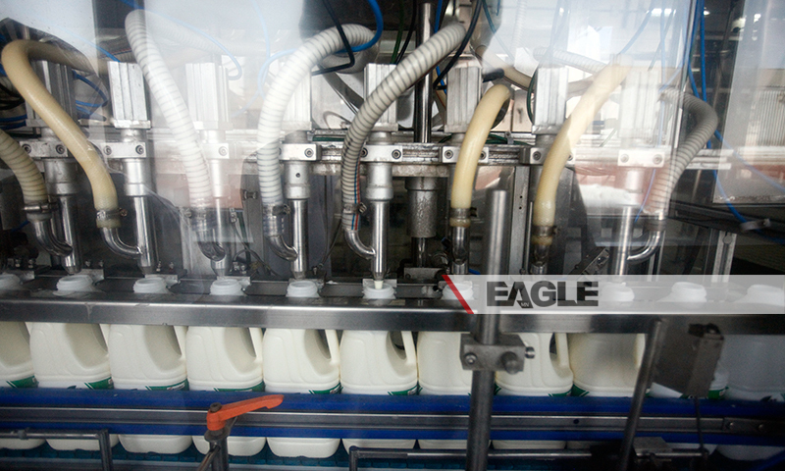

### identifier

1a7c48a4-5dec-49d2-aff2-8bab59dc117c

### creator

### type

Image

### coverage

Mongolia

### description

Goyo yogurt factory tour image published by Eagle.mn.

### publisher

### source

### rights

### subject

Mongolia

dairy

nationalism

social media

### date

2014

### language

Vitafit factory tour image - Vitafit factory tour image - v3ftj0huhqfr2ds3cgl264l1f l

### format

image/jpeg

### original filename

v3ftj0huhqfr2ds3cgl264l1f_l.jpg

### extent

365.4 KiB

800x480 px

### modified

2014-03-24 18:29:08