26801

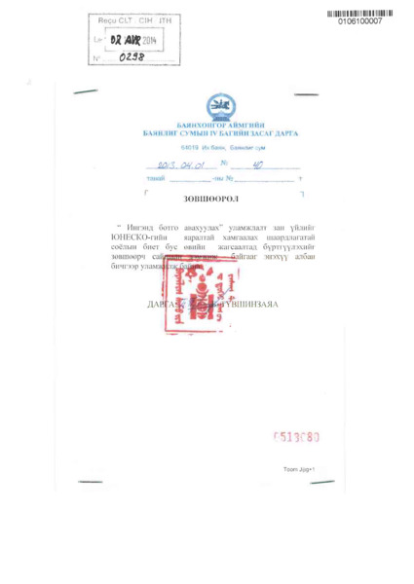

### identifier

26a0f497-55a5-4bc6-a078-6f84ab1f341d

### creator

Mongolia

### type

Text

### coverage

Mongolia

### description

Consent of communities. UNESCO List of Intangible Cultural Heritage in Need of Urgent Safeguarding, Nomination file No. 01061, “Coaxing ritual for camels” (Mongolia).

### publisher

### source

### rights

### subject

### date

### language

English

Mongolian

### original filename

26801.pdf

### extent

7.0 MiB

### format

application/pdf

### modified

2016-02-24 14:45:23