Oral history interview No. 090759A with Ariunzaya (b. 1976): translation

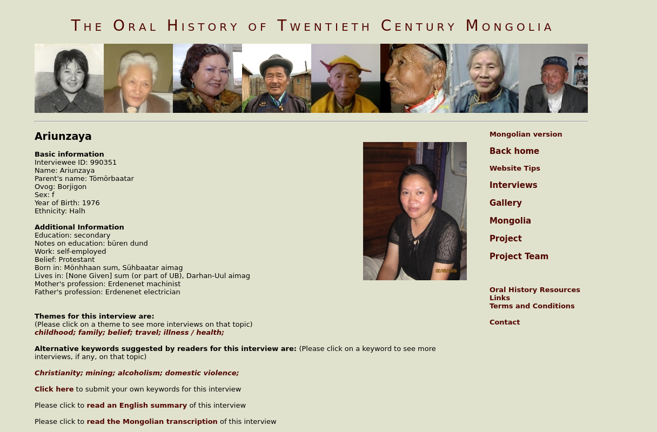

### identifier

711feb02-ea1b-4fa4-aa2c-5ae3b7311007

### creator

Ariunzaya

### type

Text

### coverage

Darkhan-Uul aimag

Mongolia

### description

Ariunzaya was born in 1976 at Bürentsogt mine, Sühbaatar aimag. When she was three years old, her parents were appointed to work at the GOK that had just been established. So they came to Erdenet to live. Erdenet was just being built and mostly Russians lived there. It was very hard during the rationed goods time [of the early 1990s] and flour was used up very quickly and kasha was used to make soup. In 1994 after completing the eighth grade she started to believe in Christ. Regretfully, her parents divorced in 1995 and a family divorce is very harmful to people especially to children. In 1996 a great congregation was organized in Ulaanbaatar and for 2-3 months Korean pastors came to organize prayer meetings. Ariunzaya took part in this meeting and she offered herself to God and went to Dornod to spread the Gospel. She lived for almost two years in Dornod and returned home to find her family to be in a very difficult situation. Her parents reunited and they both had started to drink. She together with her two younger brothers sold ice-cream to make the ends meet and soon she went back to Dornod. Her father died at the time she was going to have her second child. She overcame all physical and emotional sufferings and considers it God’s blessing to have delivered a healthy child.

### publisher

Oral History of Twentieth Century Mongolia

### source

<http://amantuuh.socanth.cam.ac.uk/search/view_trans.php?Interview=090759A>

### rights

Copyright MIASU. Reproduced with permission. Brief excerpts from interviews and other material may be used in academic or popular work for non-commercial purposes provided proper attribution and credit is given to the Oral History of Twentieth Century Mongolia and the Mongolia and Inner Asia Studies Unit (MIASU). You must not: (a) republish this material (including republication on another website) without the express written permission of MIASU; (b) sell, rent or sub-license material from the website; (c) show any material from the website in public without attribution to The Oral History of Twentieth Century Mongolia; (d) reproduce, duplicate, copy or otherwise exploit material on the website for a commercial purpose without express written permission; (e) use the material in any way that is damaging to the project or any of the persons named in the interviews. See <http://amantuuh.socanth.cam.ac.uk/terms.php> for details.

### subject

belief

childhood

family

illness

oral history

travel

### date

2009

### language

English

### format

text/plain

### contributor

Otgonbayar

### original filename

090759A-Ariunzaya-translation.url

### relation

a7069e3a-ae67-4c4b-a6e1-e4a9f1f5752f

### extent

74.0 B