Some Notes on a Visit to a ‘Mongolian’ Village in Yunnan, China

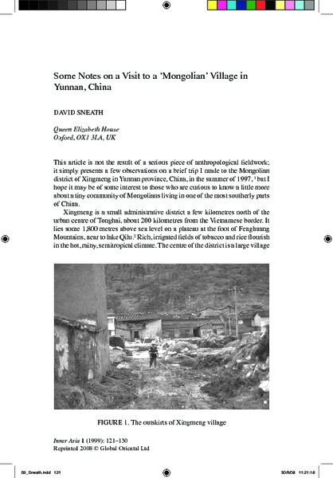

### identifier

ac47c867-6c6c-4f26-bebc-2640c6ea1475

### creator

Sneath, David

### type

Text

### coverage

PRC

Yunnan

### description

Article presenting David Sneath’s reflections on the village depicted in the photographs from this collection. From the introduction: “This article is not the result of a serious piece of anthropological fieldwork: it simply presents a few observations on a brief trip I made to the Mongolian district of Xingmeng in Yunnan province, China, in the summer of 1997, but I hope it may be of some interest to those who are curious to know a little more about a tiny community of Mongolians living in one of the most southerly parts of China.”

### publisher

Inner Asia

### source

<http://booksandjournals.brillonline.com/content/journals/10.1163/146481799793646448>

Inner Asia, Volume 1, Issue 1, pages 121 – 130

### rights

Copyright

### subject

### date

1999

### language

English

### format

application/pdf

### contributor

### original filename

Sneath1999.pdf

### relation

### extent

2.1MiB

### public

FALSE