Photographs of Dashbalbar sum, No. 48

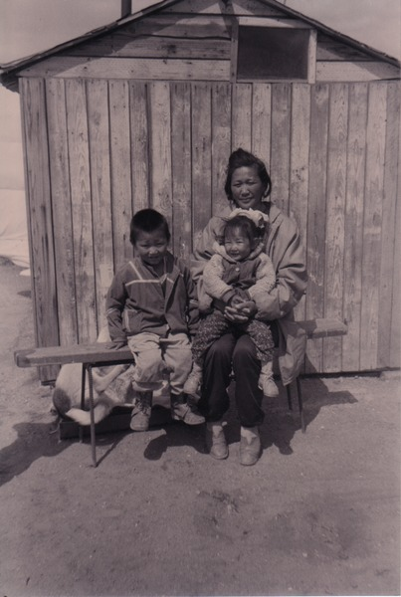

### identifier

d87b6a40-6c11-483e-b3e8-a39d1c00ce54

### creator

Batbuyan B.

### type

Image

### coverage

Dashbalbar sum

Dornod aimag

Mongolia

### description

Household No. 7, wife of D. Baatar, Tsedev, with her children. Dashbalbar sum centre.

### publisher

### source

Scanned from a photographic print held in the archives of the Mongolia and Inner Asia Studies Unit, University of Cambridge.

### rights

### subject

research participants

### date

ca. 1999

### language

### format

image/png

### contributor

### original filename

bair-batbuyan-photos-48.png

### relation

### extent

1182x1761 px

3.0 MiB